TASK 5:

* Create a Virtual Network and two Subnets.
* Launch two Windows Virtual Machine in each subnet
* The Virtual Machines should be able to ping each other.

Steps to Create two virtual network and create two separate subnet inside it, then, create two VM inside each subnet and try their connectivity:

Step 1: Create virtual network using azure virtual network service.

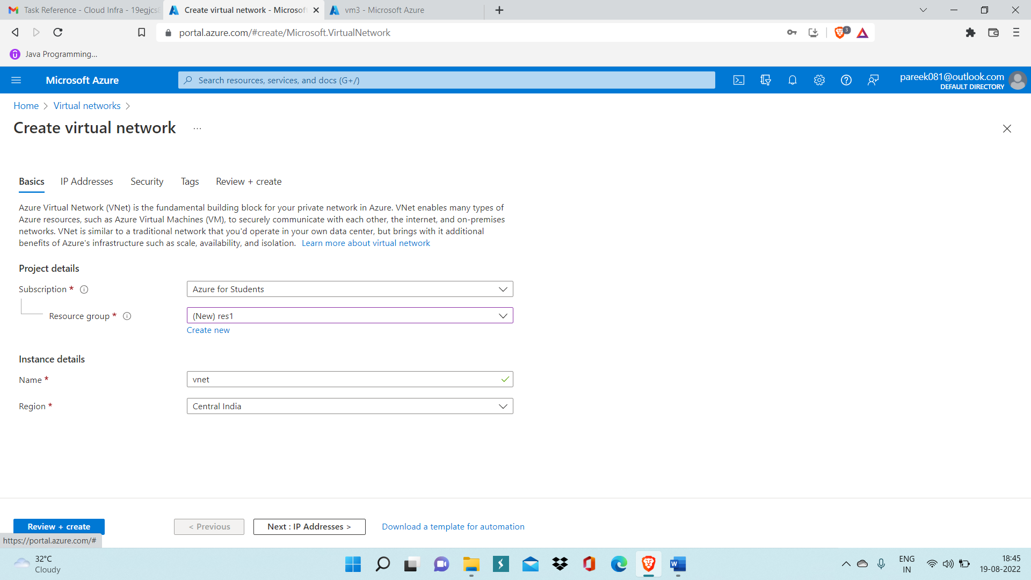

Step 2: Now, create two subnet inside this Vnet by going inside Subnet settings.

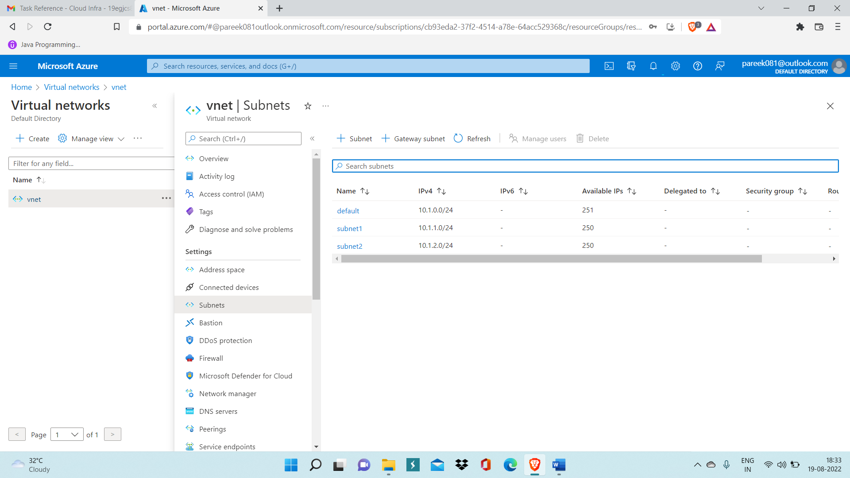

Step 3: Now, create one VM in which you will specify subnet1(one of the subnet you have created)

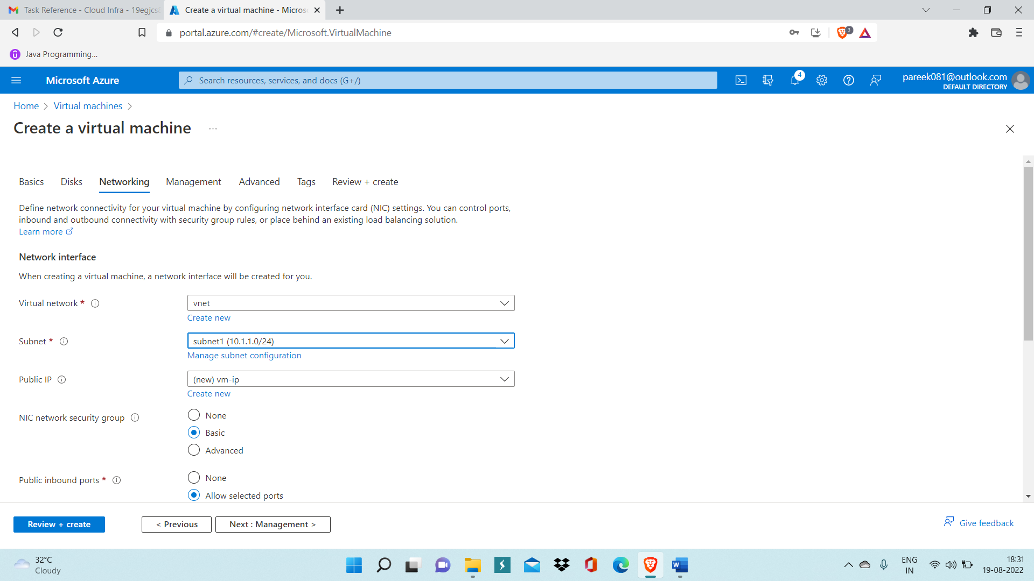

Step 4: After deployment of the VM, similarly create another VM using subnet2.

Step 5: Now open both VM by entering authentication details.

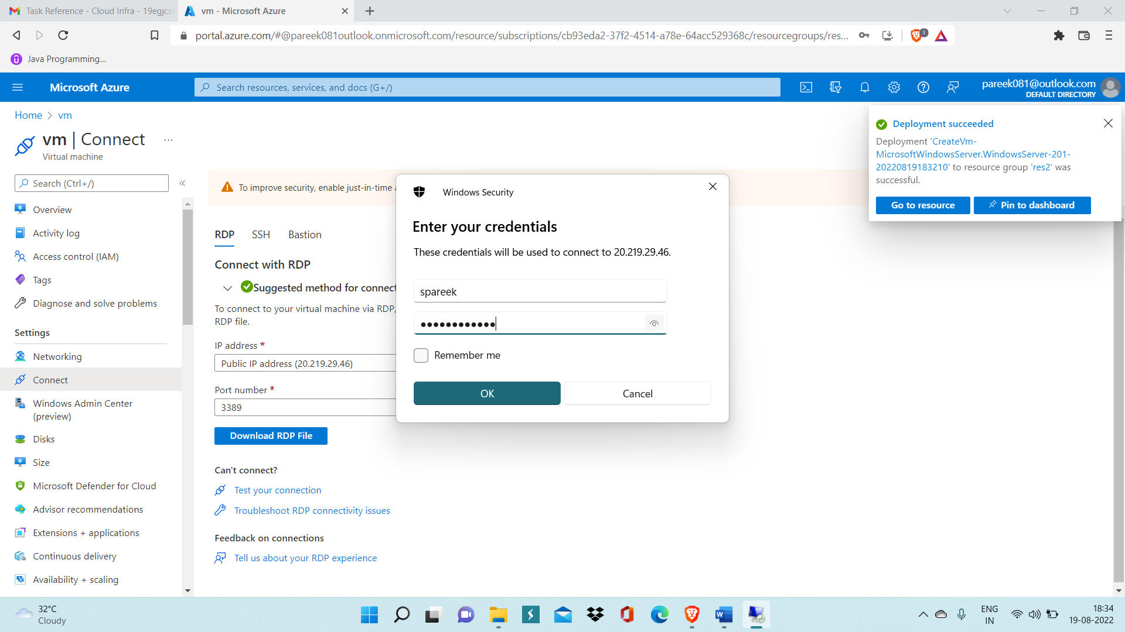

Step 6: Now inside VM, go inside Advanced firewall settings and then go inside inbound rules.

Step 7: Now enable File and Printer sharing rule for both ICMPv4 and ICMPv6 in

Both VM’s.

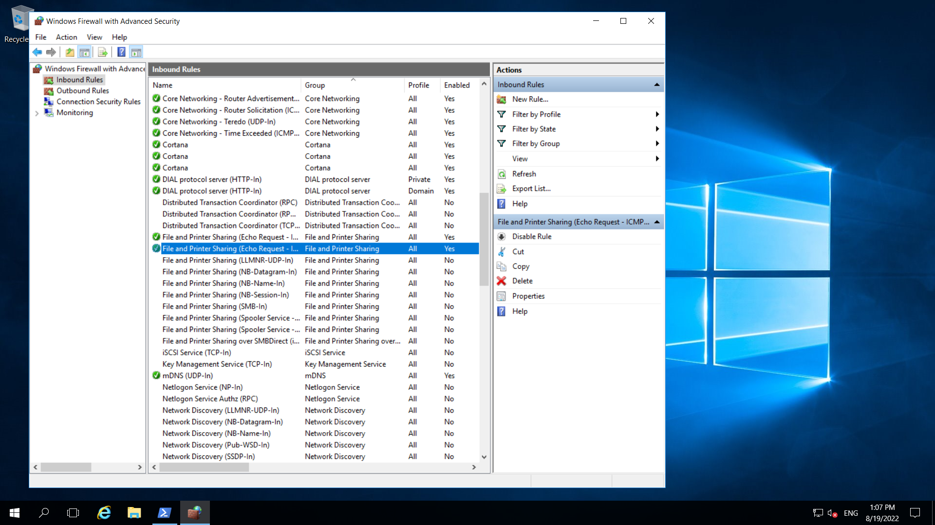

Step 8: Now open powershell window in one of the VM and write command ‘ping <private IP of another VM>’, ping command is used to test the connectivity between VM’s. For example in below image private IP of VM1 is: 10.1.2.4 and private IP of another VM is: 10.1.1.4

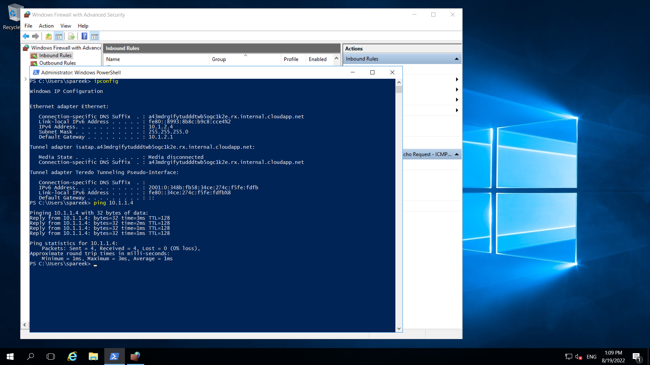

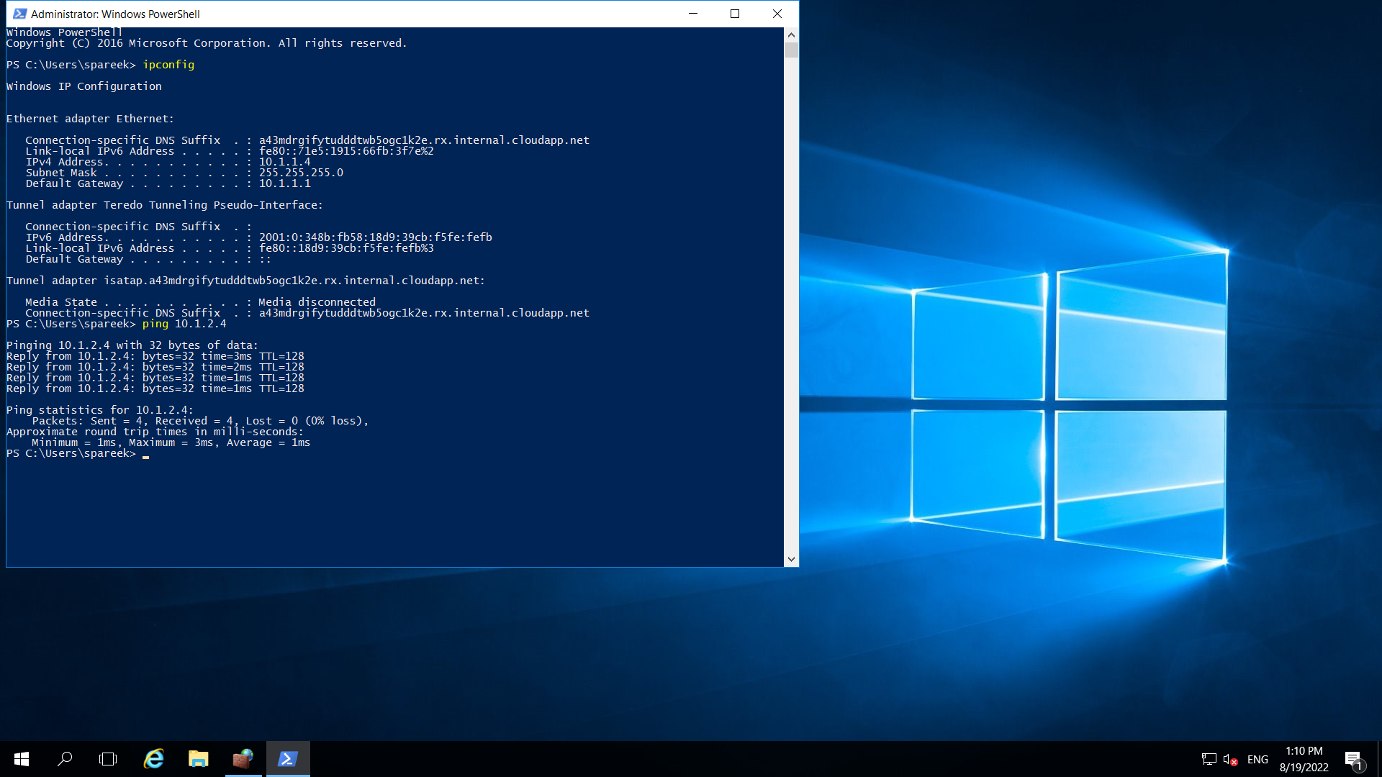

Here, it shows Two VM’s are pinged successfully.